Assignment 11: Recursive and Iterative Routines
In this assignment you will implement both recursive and non-recursive functions.
Use the starter code for this assignment that has been uploaded into this week’s folder. The code is menu driven so as to make testing more interactive.
You are to enter a sequence of numbers. Any sequence is acceptable. Therefore, you have an option that creates a new node, stores the newly entered number within the node and then adds the node to the end of the list.
You should add the same number a few times as the purpose of this program is to allow the user to enter a number and then recursively visit each node and delete all nodes that contain the number, leaving the other nodes in tact but still maintaining a linked list.
You will also write a routine to display the list in reverse order. To do this you will also create a recursive functions.
Other functions to complete are displaying the list in physical order and deleting all nodes in the list (clearing the list) to start over with a new list.
Example:
Enter a list
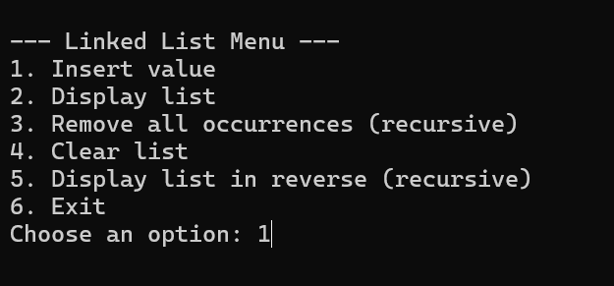
Display the list
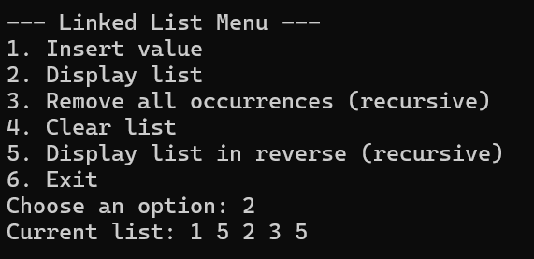
Display the list in reverse order
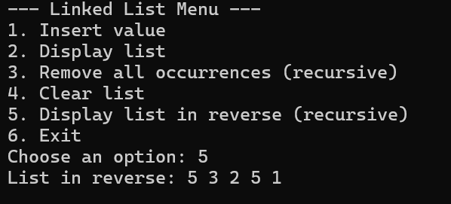
Remove all occurrences
